Exercises 2
Relationships between events illustrated.

Two screening test are available for identifying loan defaulters. These tests are used to evaluate requests for new loans.

Test A – Credit rating result: good (G) or poor (P)

Test B - Employment Status result : satisfactory (S) or not satisfactory (NS)

Statistical analysis has provided the following estimates of the test performances produced the following tables:

Sample size = 10158 loans

Default = D, non default = 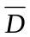

 |  | Test A
 |  | D
 | P | 135 | 1008
 | G | 255 | 8760

 |  | Test B
 |  | D
 | NS | 120 | 444
 | S | 270 | 9324

We shall estimate the probabilities from this large sample.

Dividing the cells of A by the sample size we get the following probabilities:

 |  | Test A
 |  | D
 | P | 0.01329 | 0.099232
 | G | 0.025103 | 0.862374

What we have in the table is that:

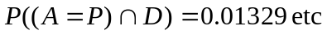

or nearly 4% of loans default.

Accuracy of the test at picking up potential defaulters is described by:
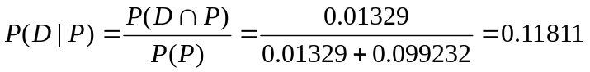

Thus 12% of people with poor credit rating default, in 88% of these cases the loan is OK.

Suppose the evaluating software applies this criterion rejecting those with the result P.

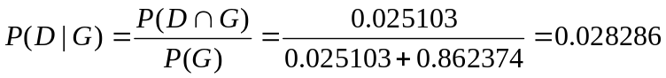

A reduction in the bad credit rate from 3.8% to 2.8%. However customers will be lost:

, 11.3% of customers are rejected.

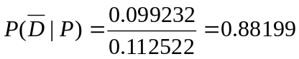 , 88.2% of these would have been OK.

Suppose an OK loan nets the company $2000, the loss on a defaulted loan is $10000.

If they don’t use the criterion they will make on (large) N loan applications:

N * (0.038393* (-10000) + 0.961607*2000)=1539.279*N

If they do then

N*0.887478*(0.028286*(-10000)+0.971714*2000)=1473.715*N

So they should leave well alone or get better info they are rejecting too many.

Exercises:

As exercise evaluate Test B in the same way.

If you could only use one test which would you use?

Applying two tests – assume conditional indpendence :

Suppose
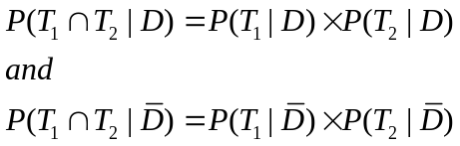

where 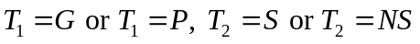.

If the following procedure is adopted:

Loan approved only if 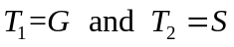 - what is the probability of a default?
What is the probability of rejecting a non-defaulter?

Using both the tests.

We now have 3 events (P,G), (S,NS) and (D,)

The two tables above do not (in general) contain enough information for the 3 event model.
What is the relationship between the tests?

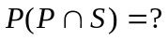
How do the tests jointly impact on P(D) ?

The full model involves 7 parameters which can be arranged in the following table:

 |  | Defaulting
Test A | Test B | D
 | NS | 108 | 432
P
 | S | 27 | 576
 | NS | 12 | 12
G
 | S | 243 | 8748

Note: the data in this table is the disaggregated version of the data in the tables above.

So that 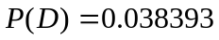 is the same as before.

We can get the probabilities as:

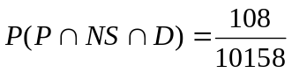 etc.

again

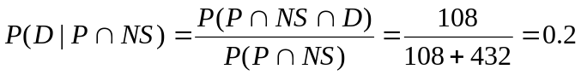

as dividing the numerator and denominator by 10158 gives the same answer.

Thus 20% of loans which fail both tests will default. 80% won’t. We might have hoped for a better result!

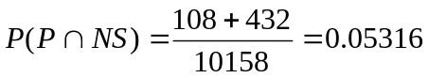 i.e. 5.3% of application fail both tests

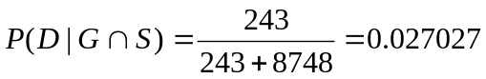 , 2.7% defaulters.

The disappointing results arise from the fact that (in this example) the test carry similar information. You are not likely to have a good credit rating if your employment status is NS.

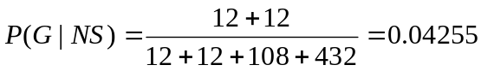 i.e. only 4.3%

but note

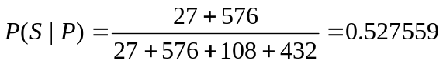 lots of people have a poor credit rating for reasons other than employment.

Models
In a 2x2 table (two events) of probabilities we have 3 parameters – 4 cells but these have to add to 1. A common parameterisation is:
1 parameter for the frequency of event A (as opposed to not(A))
1 parameter for the frequency of event B (as opposed to not(B))
1 parameter for association.- measuring the relationship.
As these are not probabilities and are measured on a log scale we defer the discussion to later in the course.

For a 2x2x2 table (three events) we have 7 parameters.
3 – for the frequencies of the events,
3 – for the binary associations between events
1 – for the triple association between events.

